**Notification Component:**

Screen without notification:

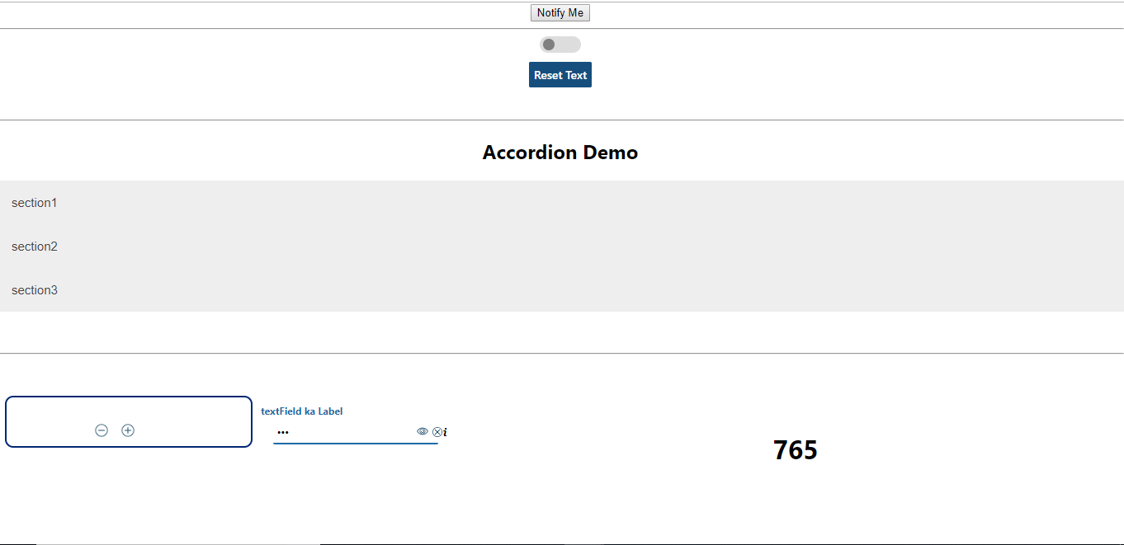

Alert msg:

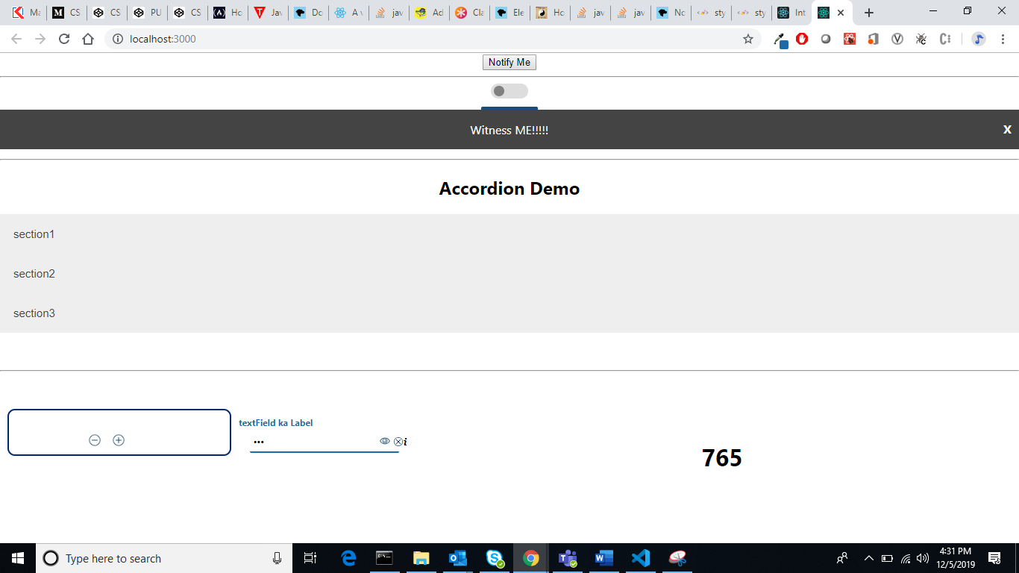

Error: 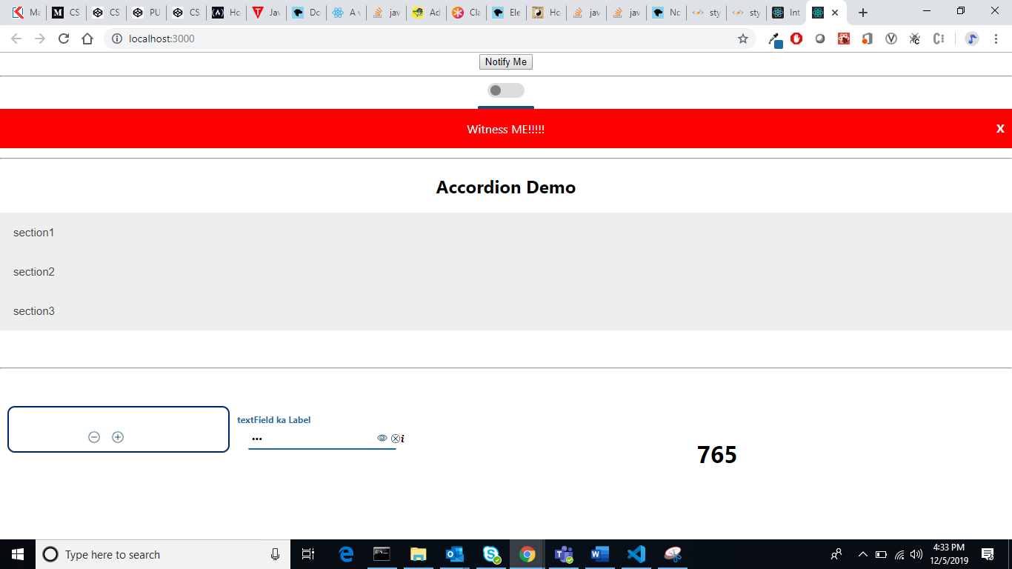

OK/ Success:

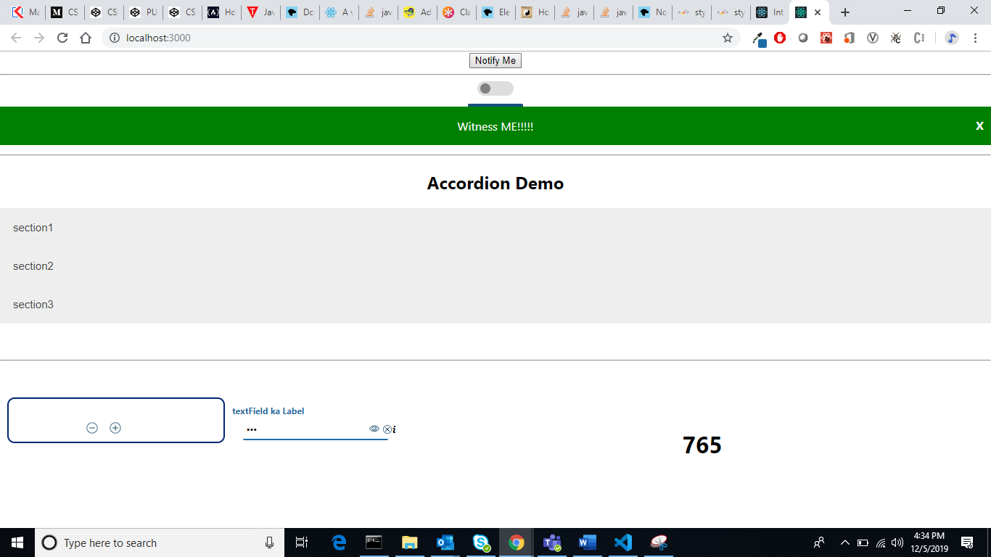

Warning:

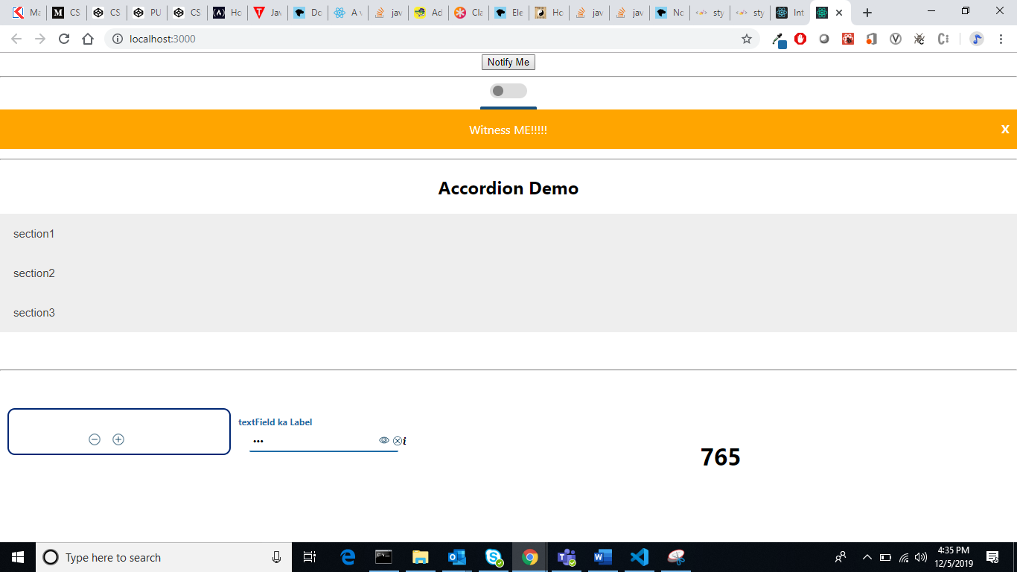

Loader:

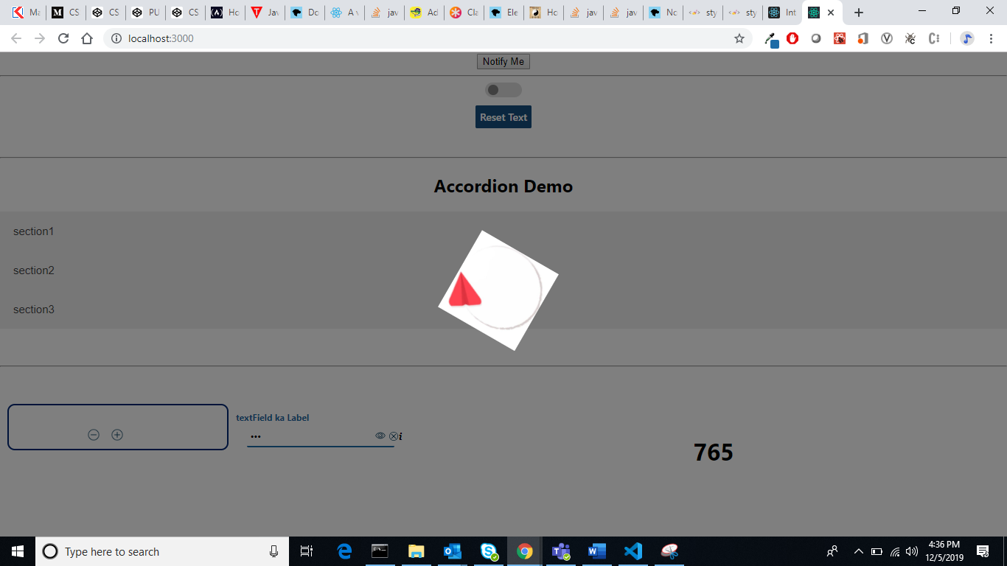

Tree Component: Expanded for input JSON..

data={[{

    "expanded": false, "name": "1",

    "fields": [

        {

            "expanded": false, "name": "11",

            "fields": [

                {

                    "expanded": false, "name": "111",

                    "fields": [{

                        "columnname": "rolename",

                        "datatype": "String",

                        "nullable": "true"

                    }, {

                        "columnname": "roleId",

                        "datatype": "String",

                        "nullable": "true"

                    }]

                }, {

                    "columnname": "rolename",

                    "datatype": "String",

                    "nullable": "true"

                }, {

                    "columnname": "roleId",

                    "datatype": "String",

                    "nullable": "true"

                }]

        }, {

            "columnname": "lasttname",

            "datatype": "String",

            "nullable": "true"

        }, {

            "columnname": "email",

            "datatype": "String",

            "nullable": "true"

        }]

},

{

    "expanded": false, "name": "2",

    "fields": [{

        "columnname": "firstname",

        "datatype": "String",

        "nullable": "true"

    }, {

        "columnname": "lasttname",

        "datatype": "String",

        "nullable": "true"

    }, {

        "columnname": "email",

        "datatype": "String",

        "nullable": "true"

    }]

},

{

    "expanded": false, "name": "3",

    "fields": [{

        "columnname": "projectName",

        "datatype": "String",

        "nullable": "true"

    }, {

        "columnname": "artifactId",

        "datatype": "String",

        "nullable": "true"

    }, {

        "columnname": "groupId",

        "datatype": "String",

        "nullable": "true"

    }]

}]

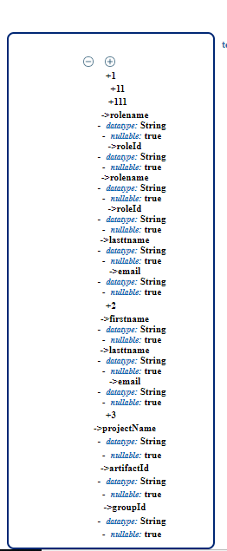

Text Field:

        <TextField placeholder='TextField placeholder'

        type ='email' step='5'

        maxlength='100'

        minlength='10'

        pattern=".+@beststartupever.com"

          label='Label'

          allowPeekingPassword

          showError={this.state.errorBoolean}

          error='validation fails'

          // readOnly

          onChange={this.onChangeTextField}

          value={this.state.anyVar}

          onClickCancel={

            ()=>{this.setState({ anyVar: '' })}}

        // password

        /><br />

Default:

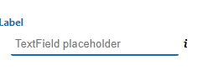

With password:

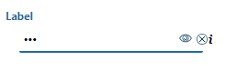

With password peeking: clicking on eye ..

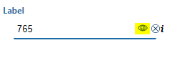

With tool tip:

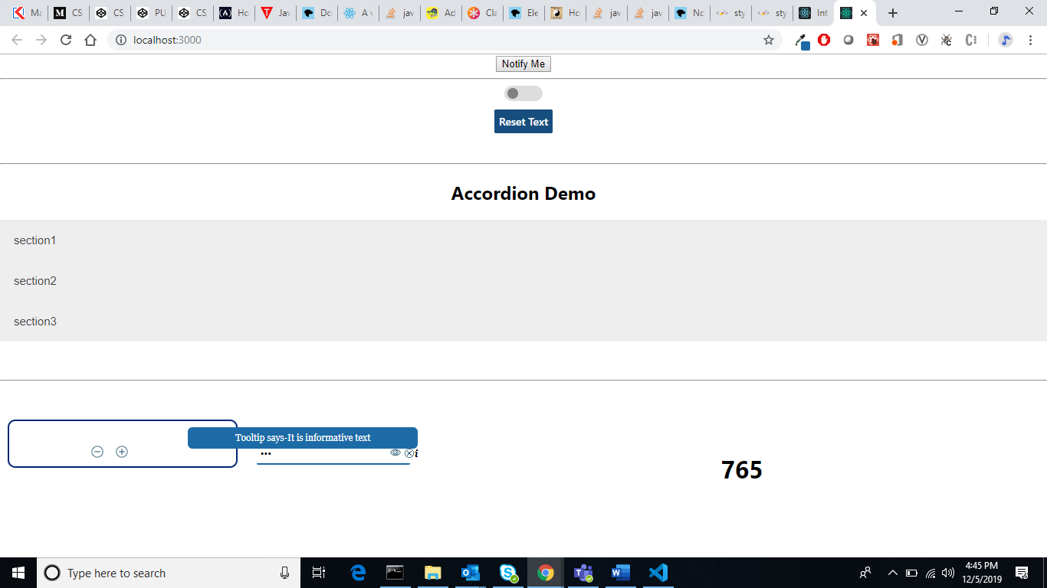

With type= number

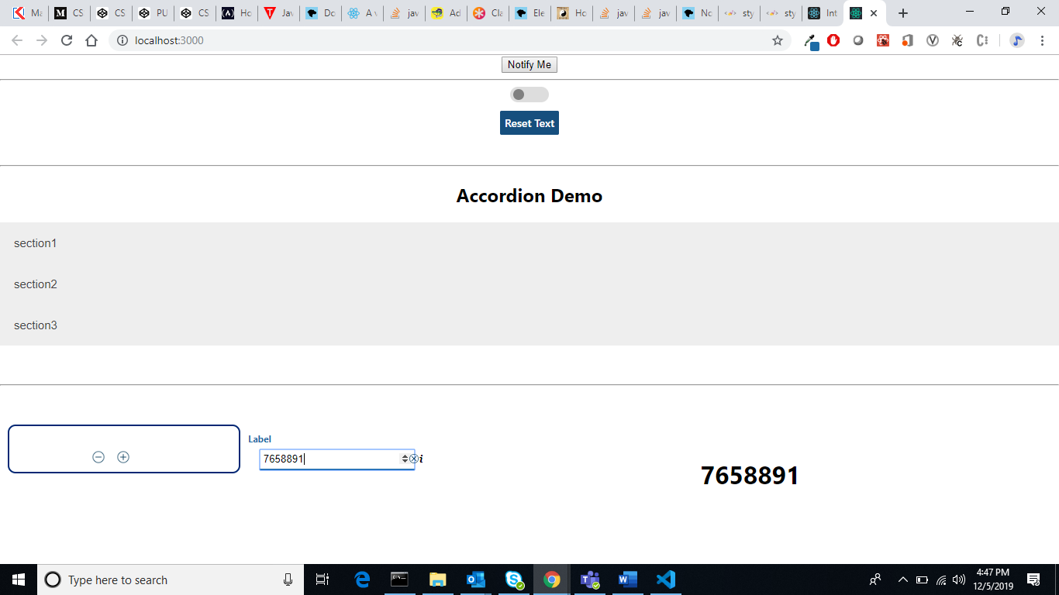

With validation fail and error message:

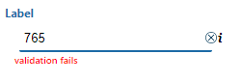

**ACCORDIAN:**

**Closed:**

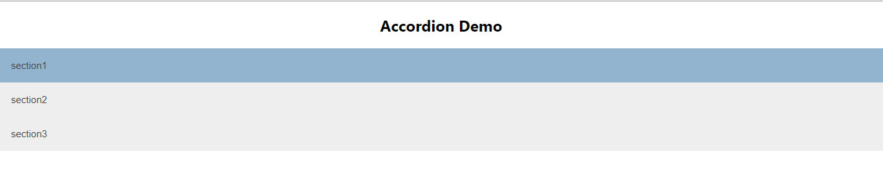

**Open:**

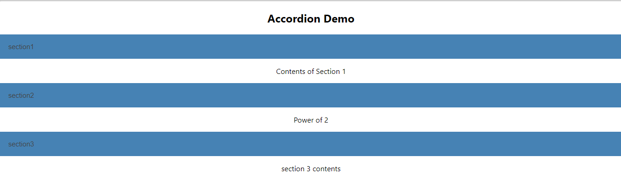

**Button:**



**Toggle:**

**Off:**



On:



On select: highlight with focus

